CHAPTER 4 – ACCOMPLISHMENTS
Member: Cheng Wen chi
I worked in different parts of the project. In each sub part, I worked by studying algorithm, coding and testing. There are 2 main session which I focused on. The first is the establishment and maintenance of overall topology in P2PTV system. The second session is the construction and reconstruction of data chunk with buffering system.

In the first session, my goal is to implement an effective algorithm to build the topology which provides a reliable connection between peers. These connections will support the exchange of large amount time sensitive data packet. After discussed with my groupmates and Professor, we decided to use the tree push models as the bases of P2P TV. Thus, I started to study the tree algorithm and find the effect algorithm to build the topology.
In the tree models, studies indicate that there are mainly 2 ways to increase efficiency.
- Keep an almost balanced tree without reconnection
- Keep peers with larger bandwidth in near to roots
In computer science, there are different algorithms to maintain a balanced tree. E.g. AVL tree. Those algorithms require the changes of relationship between nodes when balancing the tree. This means disconnection and reconnection of peers is a must to applying those algorithms in tree push system. However, disconnection and reconnection cause a large overhead when I am tested it over the internet. The control message exchanges between peers for initial new connection cause a large overhead.

Thus, I rejected the idea of reestablish connection and started to focus on peer initial join problem and reconnection problem. As to reduce the depth of tree, peer should join peer that near the root when they join the system. As a result, the depth of each node in the tree becomes the most important information to determine the joining peers. As to simply the determination of nodes depth, I proposed to build a tracker server which provides similar function as tracker in P2P file sharing system. The tracker server in the P2PTV system will become a centralized database for Peer information. This information will include IP address, nodes depth, and bandwidth.
Tracker will maintain all Peer information of both video server and peers and provided to peer for connection establishment.
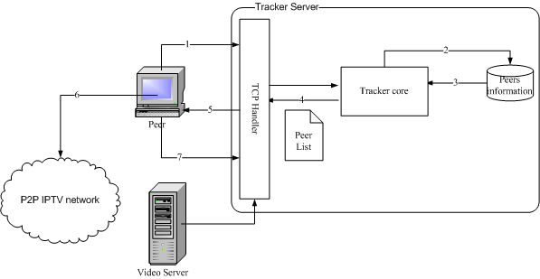
Figure 1.2 Implementation of tracker
In figure 1.2, it shows the implementation idea of the tracker system. In the P2PTV system, Tracker server will be the first session to start up. Tracker will then started to listen require message from video server and normal peers in system. When a new channel is started by a video server, the video server will register its channel information to Tracker Server.

When a new peer joins the P2PTV system, it will send a request message to the tracker server. The tracker core will then get request information from TCP handler and it will compute an appropriate peer list. The Peer list is lists that contain details of peers which provide service to others peer. When the Peer received the Peer list, it will attempt to establish a new connection with those peer based on its local policy. The process of peer selection is computed in client because I want to reduce the workload of tracker server. After it connected to peers, it will give the feedback message to the tracker and the tracker will updated its peer list.

In the current Phase, tracker server is implemented and it allow to keep all the peers information. However, there is problem on updating the disconnected peers. The current algorithm causes a very TCP overhead on detecting the disconnected peers in P2P system. It greatly increases the load of tracker server. The peer update algorithm should be redesign to increase the availability of the tracker server.
The next part that I response for is the buffering algorithm in the P2PTV system.
The goal of the buffer is to support the sub streaming algorithm and enhance the playback quality of the streaming video.
As sub stream is received from different peer by different threads in the program, the buffer should provide a platform for the playback thread and the network streaming thread to exchange data chunk.

The figure below show the structure of the buffer system:
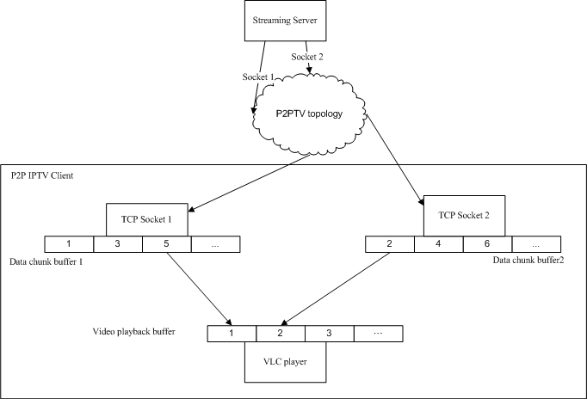
The designed of buffer system is actually based on the cool streaming algorithm. When network thread receive data chunk from peer, it will store the data chunk in is chunk buffer. At the same time, the video reconstruction thread will read the chunks in each data buffer and reconstruct the original video stream based on their sequence number. The reconstructed buffer will then move to video playback buffer and it will then played by VLC player thread.
The multithreading process causes a great difficulty on implementation. As the merging thread, network thread and playback thread are operated parallel in system, the buffer may read and write by different threads at the same time. This needs a well defined algorithm synchronize the thread. The miss handling of thread may causes playback over flow problem or lagging problem in video playback.

